

FACULTY OF TECHNOLOGY AND ENGINEERING
DEVANG PATEL INSTITUTE OF ADVANCE TECHNOLOGY AND RESEARCH
DEPARTMENT OF INFORMATION TECHNOLOGY

A.Y. 2026-27 [SEMESTER 3]

LAB MANUAL

CEUE203: Object Oriented Programming


Practical 6

Interfaces, lambdas, and packages
Problem Statement:
1. Remote control: use Switchable devices, a default toggle, and an anonymous class and lambda policy.
2. Notification senders: broadcast through functional-interface lambdas and repeat urgent notifications.
3. Discount engine: choose a lambda rule at runtime and apply it to a list of prices.
Expected Output: The sample programs demonstrate the required behavior; see the captured console output below.

Solution:

DiscountEngine.java
import java.util.List;
import java.util.Scanner;
import java.util.function.UnaryOperator;
public class DiscountEngine {
public static void main(String[] args) {
List<Double> prices = List.of(100.0, 250.0, 500.0);
try (Scanner scanner = new Scanner(System.in)) {
System.out.print("Choose discount (1=10%, 2=20%, 3=flat 25): ");
int choice = scanner.nextInt();
UnaryOperator<Double> discount = switch (choice) {
case 1 -> price -> price * 0.90;
case 2 -> price -> price * 0.80;
case 3 -> price -> Math.max(0, price - 25);
default -> throw new IllegalArgumentException("Choose 1, 2, or 3.");
};
prices.stream().map(discount).forEach(price ->
System.out.printf("Discounted price: %.2f%n", price));
}
}
}

NotificationDemo.java
@FunctionalInterface
interface Notifier {
void send(String message);
}
interface Urgent { }
public class NotificationDemo {
private static final class EmailNotifier implements Notifier, Urgent {
@Override public void send(String message) {
System.out.println("Email: " + message);
}
}
private static final class SmsNotifier implements Notifier {
@Override public void send(String message) {
System.out.println("SMS: " + message);
}
}
public static void main(String[] args) {
Notifier[] senders = {new EmailNotifier(), new SmsNotifier(),
message -> System.out.println("Push: " + message)};
String message = "Your account statement is ready.";
for (Notifier sender : senders) sender.send(message);
for (Notifier sender : senders) {
if (sender instanceof Urgent) {
sender.send("URGENT: " + message);
sender.send("URGENT: " + message);
}
}
}
}

RemoteControlDemo.java
interface Switchable {
void on();
void off();
default void toggle() {
off();
on();
}
}
public class RemoteControlDemo {
private static final class Fan implements Switchable {
@Override public void on() { System.out.println("Fan on"); }
@Override public void off() { System.out.println("Fan off"); }
}
private static final class Light implements Switchable {
@Override public void on() { System.out.println("Light on"); }
@Override public void off() { System.out.println("Light off"); }
}
@FunctionalInterface
private interface SwitchPolicy {
boolean maySwitchOn(String device, int hour);
}
public static void main(String[] args) {
Switchable[] devices = {new Fan(), new Light()};
for (Switchable device : devices) device.toggle();
SwitchPolicy anonymousPolicy = new SwitchPolicy() {
@Override
public boolean maySwitchOn(String device, int hour) {
return hour >= 7 && hour < 22;
}
};
SwitchPolicy lambdaPolicy = (device, hour) -> hour >= 7 && hour < 22;
System.out.println("Anonymous policy at 20: "
+ anonymousPolicy.maySwitchOn("Fan", 20));
System.out.println("Lambda policy at 6: " + lambdaPolicy.maySwitchOn("Light", 6));
}
}

MiniBank Project Work:

MiniBank progress ? Practical 6
Completed: Transactable and InterestBearing capabilities, default yearly interest, the WithdrawRule functional interface, and the Premium marker interface. The central project organizes code into model, util, repository, and service packages.
Single project location: Java Programs\Minibank

Progressive source excerpts:

Minibank/src/main/java/minibank/model/Transactable.java
package minibank.model;
import minibank.exception.InsufficientFundsException;
import minibank.exception.InvalidAmountException;
public interface Transactable {
void deposit(long amount) throws InvalidAmountException;
boolean withdraw(long amount) throws InsufficientFundsException, InvalidAmountException;
}

Minibank/src/main/java/minibank/model/InterestBearing.java
package minibank.model;
public interface InterestBearing {
double interestRate();
default double yearlyInterest() {
return getBalance() * interestRate() / 100.0;
}
long getBalance();
}

Minibank/src/main/java/minibank/model/WithdrawRule.java
package minibank.model;
@FunctionalInterface
public interface WithdrawRule {
boolean allow(Account account, long amount);
}

Minibank/src/main/java/minibank/model/Premium.java
package minibank.model;
public interface Premium { }

Output Screenshot:
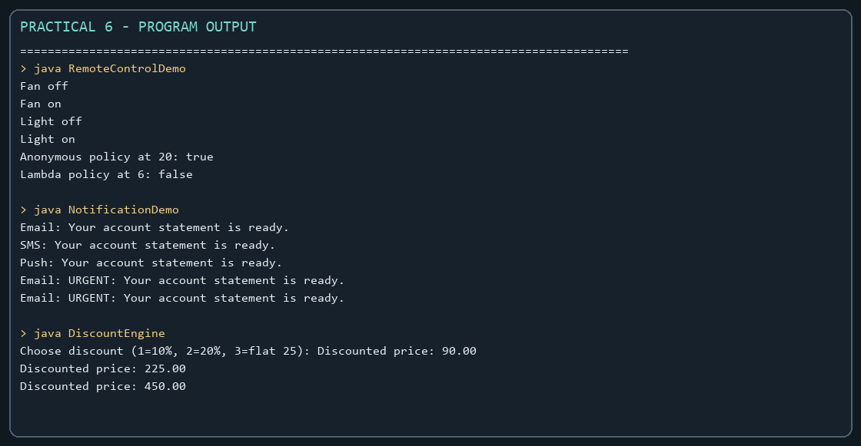
Captured from the compiled practical programs.

